L.A. “Butch” Hibben sawphist@gmail.com
951-322-5977

http://audacityteam.org/

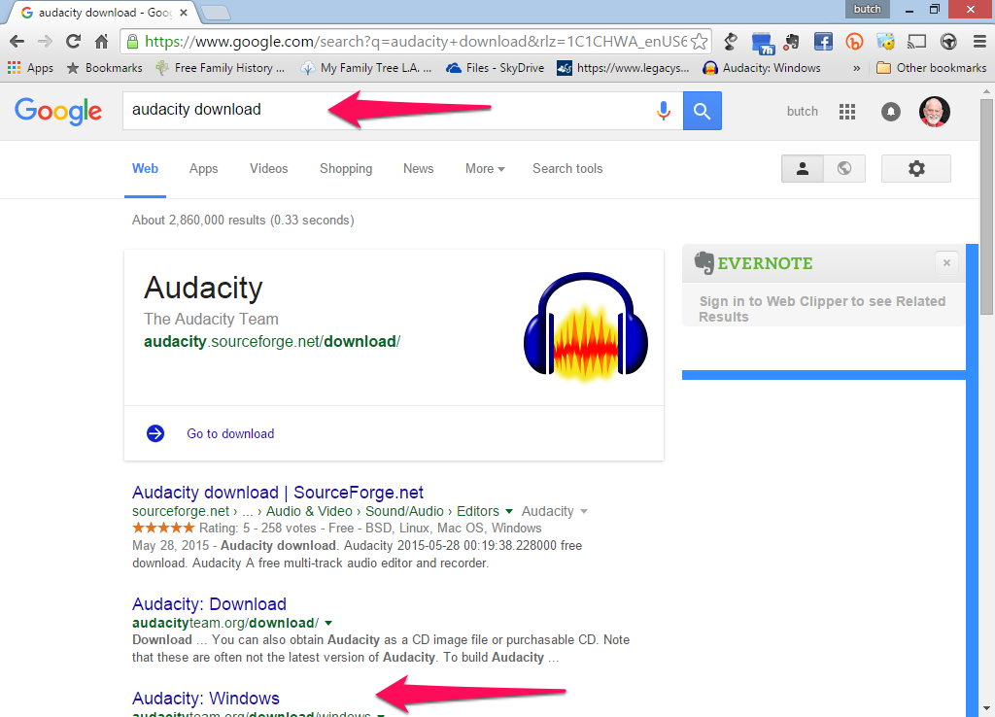
Again click on windows
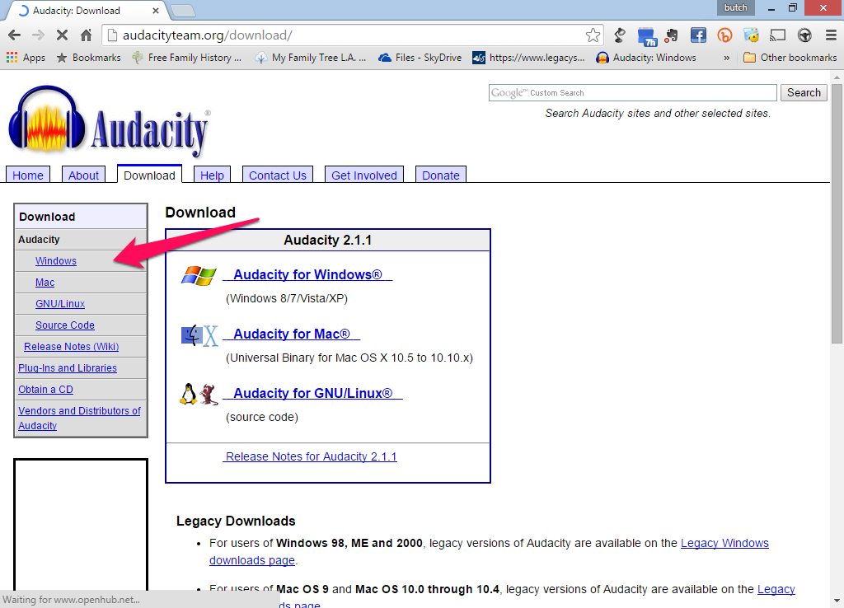
You are now going to download three programs
- Audacity installer
- Lame MP3 encoder
- FFmpeg import/export library
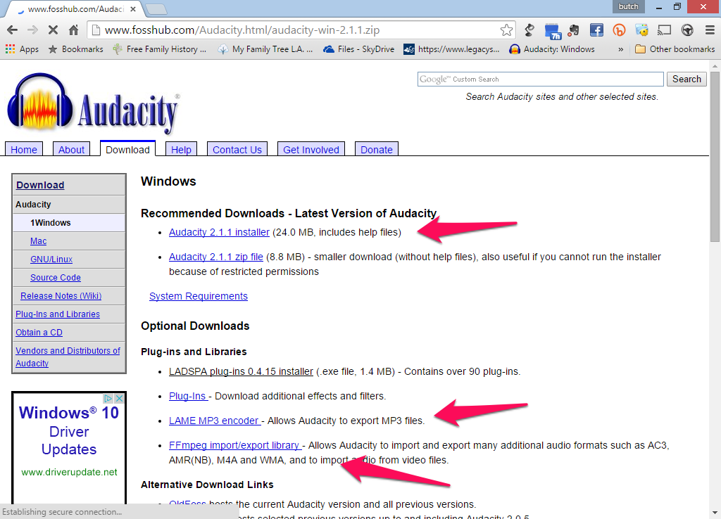
These are the toolbars you will see when you start the program. The device toolbar will allow you to select where you will record from and playback to. The transport toolbar will allow you to record and playback your data.
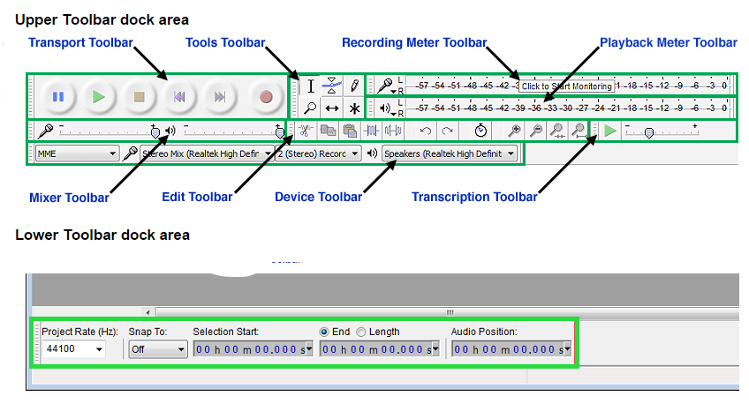
When you have questions please contact me via e-mail or phone and I will be glad to help. Thanks, Butch Hibben

